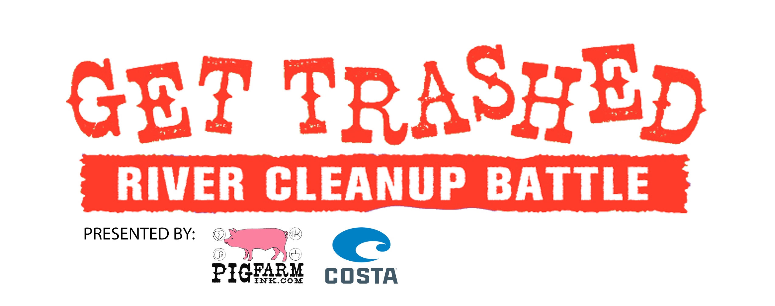
Date:

Kick Off Location:
“Weigh In”:

1. Area restricted to all waters…
2. All scorable items must be photographed and posted to Instagram #yourteamname, #GetTrashed, #KickPlastic, #PigFarmInk
3. New Anglers 1st fish on a fly- 25 pts, all other fish- 10 pts
4. All other Angler’s fish- 1 pt each
5. Carp bonus 25 pts
6. Each contractors bag full of garbage – 50 pts each (your own drink containers count)
7. Individual objects that don’t fit in bag are 25 pts each
8. Shotgun koozie action photos/videos posted to Instagram #PFIShotgunKoozie #PigFarmInk 10 pts.
9. Get a bad tattoo 100 pts each
10. Worst tattoo of the event (voted on social media) wins prize pack

- Scoring is based on the honor system, and all teams are responsible for keeping their own score. Winning team receives a pair of Costa sunglasses.
- All garbage must be brought to collection station at Illegal Pete’s
- Irresponsible behavior will be loosely tolerated and asshats kicked directly in the face

